

**CSE115, Section -12**

**Project Report**

**Topic: Online Shop**

**Submitted By:**

**Name:** Abu Mukaddim Rahi.

**ID:** 2022027642.

**Section:** 12.

**Faculty : NVA**

**Depertment:** Computer Science and Engineering.

**Submitted To:**

**Md. Tanzil Shahria**

CSE Depertment(NVA)



Project Name:

**Online Shop**

Summary:

The name of my project is Online Shop. If anyone wishes to enter my shop then they'll have to submit their name, their country, and contact number. They'll be given 5 options such as; display products, search products, buy products, change products, and add products. Among these options, the first 4 options are for customers where the last option is for the manager. Firstly if anybody chooses option 1, then all the products in my shop will be displayed to them. If anyone wishes to search for products, they'll be showing 5 types of products which are books, shoes, mobiles, clothes, computer accessories. They can click on any of these options of their choice and if there's any product in our shop according to their selection then it'll be pointed out to him. And if we don't have the collection of the chosen product by the customer then the system will show them the message 'Product not found' or 'Not in stock'. If anyone wants to buy products then they'll have to press the 3rd option and as result, the system will display the five mentioned products to them. If anyone chooses the first option, which is Books then they'll have to press 1 and the names of the books stocked in our shop, prices, and quantity will be displayed to them. Then the system will ask them about the book that they want to buy and another message for conformation will be sent to the customer. If the customer confirms their purchase, the system will enter that particular product. After that, he'll be shown on the home page again so that he can buy more products or enter other options. When he will try to exit from the program, he'll be notified about his total expenditure. All the other options from Buy products work in a similar process. If anyone enters the 4th option which is change products then they'll be asked about the product that they want to change. The system will enter the product chosen by the customer for change and will ask for the customer's information. After that, the customer will be asked specifically about the product that he wants to change and his request will be entered. If anyone chooses the 5th option which is for managers, they'll be asked to enter their username and password and they can successfully add any product.

Functions name list:

Standard library functions:

printf()

scanf()

gets()

Defined functions:

void Tolower( ) : This function is used for converting a string into lowercas.

void printProducts( ) : For printing the products function.

void AddProducts( ) : For add the products.

void SearchProducts( ) : For searching products.

**Coad :**

#include <stdio.h>

#include <string.h>

#include <ctype.h>

struct OnlineShop

{

char name[1000];

double rate;

int quantity;

char type[100];

};

void Tolower(char s[])

{

int i;

for (i = 0; s[i]!='\0'; i++) {

if(s[i] >= 'A' && s[i] <= 'Z') {

s[i] = s[i] + 32;

}

}

};

void printProducts(struct OnlineShop *os, int size)

{

int i;

for(i=0;i<size;i++){

if(os[i].quantity!=0){

printf("\n\n\t\t%d->%s, Quantity:%d, -BDT:%.2lf",i+1,

os[i].name,

os[i].quantity,

os[i].rate

);

}

else{ continue;}

}

};

void AddProducts(struct OnlineShop *os,int num)

{

char nam[1000],type[100];

double rat;

int quan;

printf("\t\tEnter Product name:");

fflush(stdin);

gets(nam);

strcpy(os[23].name,nam);

printf("\t\tEnter Product quantity:");

fflush(stdin);

scanf("%d",&quan);

os[23].quantity = quan;

printf("\t\tEnter Product rate:");

fflush(stdin);

scanf("%lf",&rat);

os[23].rate = rat;

printf("\t\tEnter Product Type:");

fflush(stdin);

gets(type);

strcpy(os[23].type,type);

printProducts(os,num);

printf("\n\n\t\tProduct Added Successfully!!!!");

printf("\n\n\t\tName:-> %s",os[23].name);

printf("\n\t\tQuantity:-> %d",os[23].quantity);

printf("\n\t\tRate:-> %.2lf",os[23].rate);

printf("\n\t\tType:-> %s",os[23].type);

}

void SearchProducts(struct OnlineShop *os, int size, char product[],int type)

{

int i,count=0;

char objProduct[100]="";

for(i=0; i<size; i++)

{

Tolower(product);

strcpy(objProduct,os[i].name);

Tolower(objProduct);

if(strcmp(objProduct,product)==0)

{

printf("\n\t\t\t%d->[%s]\tQuantity:%d\tPrice:%.2lf BDT", //print exactly matched string

i+1,os[i].name,os[i].quantity, os[i].rate );

count+=1;

break;

}

else if((strncmp(objProduct,product,4)==0 || strncmp(objProduct,product,5)==0 || strncmp(objProduct,product,8)==0 ||

strncmp(objProduct,product,6)==0 || strncmp(objProduct,product,7)==0 || strncmp(objProduct,product,9)==0) && (type!=3))

{

printf("\n\t\t\t%d->[%s]\tQuantity:%d\tPrice:%.2lf BDT", //print matches with 7 char

i+1,os[i].name,os[i].quantity, os[i].rate );

count+=1;

}

else if((strncmp(objProduct,product,9)==0 || strncmp(objProduct,product,10)==0 || strncmp(objProduct,product,11)==0) && (type==3))

{

printf("\n\t\t\t%d->[%s]\tQuantity:%d\tPrice:%.2lf BDT", //print matches with 7 char

i+1,os[i].name,os[i].quantity, os[i].rate );

count+=1;

}

else if(i==size-1 && count==0)

{

printf("\n\t\tSearch not found");

break;

}

else{ continue;}

}

};

int main()

{

char Name[20], Country[20];

int Mobile_No;

printf("\t * Please give your personal informations *");

printf("\n Name\t :: ");

scanf(" %[^\n]s", Name);

printf("Country\t :: ");

scanf(" %[^\n]s", Country);

printf("Mobile No.:: ");

scanf("%d", &Mobile_No);

printf("\n Hello %s \n \n \t********** Welcome to our Online Shop ****** \n", Name);

printf(" ------------------------------ \n", Name);

struct OnlineShop b[30] = {

{"Harry porter Bookset(1-7)", 8000.00,7, "books"},

{"Hamlet", 500.00, 1, "books"},

{"A Golden Age ", 1000.00,1, "books"},

{"A gna Karenina", 1500.00,1, "books"},

{"Romeo and Juliet", 1200.00,1, "books"},

{"Merchant of Venice", 1500.00,1, "books"},

{"The Unfinished Memoirs", 350.00,1, "books"},

{"A Game of Thrones", 1250.00,1, "books"},

{"Breaking Dawn", 1050.00,1, "books"},

{" Oresteia", 1200.00,1, "books"},

{"Misir Ali Omnibus 1", 1000.00,9, "books"},

{"Misir Ali Omnibus 2", 1500.00,5, "books"},

{"Himu Series(1-23)", 4105.00,23, "books"},

{"Flowers of Flame", 500.00,1, "books"},

{"Paradoxical Sajid 1 & 2", 800.00,2, "books"},

{"Ma, Ma, Ma ebong Baba", 300.00,1, "books"},

{"Bela_furabar_age", 250.00,1, "books"},

{"Be Smart with Muhammad ", 650.00,1, "books"},

{"Golpoguccho", 750.00,1, "books"},

{"Dipu Number Two", 300.00,1, "books"},

{"Agnibina", 200.00,1, "books"},

{"Nazruler Chotogolpo somogro", 650.00,1, "books"},

{"Padma Nadir Majhi", 300.00,1, "books"}

};

struct OnlineShop s[30] = {

{"Black Color Leather Formal Shoe For Men", 3300.00, 1, "Apex"},

{"Master Color Leather Party Formal Shoe For Men", 3250.00, 1, "Apex"},

{"Black Color Leather Formal Shoe For Men", 3300.00, 1, "Apex"},

{"Sprint Royal Blue Kniting Sneaker for Men", 2790.00, 1, "Apex"},

{"Fashion for Men Lining Side Zipper Pointed Toe Ankle Boots", 4400.00, 1, "Apex"},

{"Leather Sandal For Men Black colour", 2490.00, 1, "Apex"},

{" Coffee Pu Sandal for Men", 1693.00, 1, "Apex"},

{"Chocolate Color Leather Formal Shoe For Men", 2000.00, 1, "Bata"},

{"Chocolate colour Leather Formal Shoe For Men ", 2500.00, 1, "Bata"},

{"Slip Men Women Outdoor Sports Aqua Water Shoes", 1200.00, 1, "Bata"},

{"Fly Synthetic Two Strap Sandal for Men", 650.00, 1, "Bata"},

{"North Star Synthetic Casual Lifestyle Sneakers - Blue", 650.00, 1, "Bata"},

{"Black Casual Slip-On Shoe For Men", 850.00, 1, "Bata"},

{"Nike_Airmax 2090 Sneakers For Men", 4990.00, 1, "Nike"},

{"Nike Men's Slipper - 310 (Black) For Men", 899.00, 1, "Nike"},

{"PUMA Men's Tazon 6 Fracture FM Cross-Trainer Shoe", 7690.00, 1, "Puma"},

{"PUMA Men's Roma Basic Sneaker(white)", 8200.00, 1, "Puma"},

{"PUMA Men's Super Liga Og Sneaker", 8992.00, 1, "Puma"},

{"PUMA Men's Smash V2 Sneaker", 9500.00, 1, "Puma"},

{"Adidas_Nite_Jogger_3M_Silver Metallic", 5200.00, 1, "Adidas"},

{"New Style Flip Flop Slipper For Men", 900.00, 1, "Adidas"},

{"Adidas Men's Grand Court Sneaker", 5300.00, 1, "Adidas"},

{"Adidas Men's Daily 2.0 Sneaker", 7500.00, 1, "Adidas"},

{"Adidas Men's Alphabounce 3 Running Shoe", 6970.00, 1, "Adidas"},

{"Brown Mixed Leather Chain Boot for Men", 3500.00, 1, "Sky sea"}

};

struct OnlineShop m[30] = {

{"Samsung A60 6GB/128GB", 24500.00, 1, "Samsung"},

{"Samsung A80 8GB/128GB", 49500.00, 1, "Samsung"},

{"Samsung M31 8GB/128GB", 27999.00, 1, "Samsung"},

{"Samsung S10+ 8GB/128GB", 99900.00, 1, "Samsung"},

{"Samsung S20 8GB/128GB", 87203.00, 1, "Samsung"},

{"Realme 6i 4GB/128GB", 17000.00, 1, "Realme"},

{"Realme 6 Pro 8GB/128GB", 24500.00, 1, "Realme"},

{"Realme 7 Pro 6GB/128GB", 27000.00, 1, "Realme"},

{"Realme X 8GB/128GB", 25000.00, 1, "Realme"},

{"Realme X 8GB/128GB", 39000.00, 1, "Realme"},

{"Redmi K20 6GB/128GB", 27000.00, 1, "Xiaomi"},

{"Redmi K20 Pro 8GB/128GB", 49999.00, 1, "Xiaomi"},

{"Redmi K30 6GB/128GB", 22500.00, 1, "Xiaomi"},

{"Redmi K30 Pro 8GB/128GB", 45500.00, 1, "Xiaomi"},

{"Redmi Note9 Pro Max 6GB/128GB", 24000.00, 1, "Xiaomi"},

{"iPhone 7 Plus 3GB+128GB", 59990.00, 1, "Apple"},

{"iPhone XR 3GB+256GB", 98000.00, 1, "Apple"},

{"iPhone XS 4GB+256GB", 74000.00, 1, "Apple"},

{"iPhone X 3GB+256GB", 96999.00, 1, "Apple"},

{"iPhone 11 4GB+256GB", 99999.00, 1, "Apple"},

{"OnePlus 6 8GB+128GB", 44990.00, 1, "OnePlus"},

{"OnePlus 6T 8GB+128GB", 54500.00, 1, "OnePlus"},

{"OnePlus 7 8GB+256GB", 52500.00, 1, "OnePlus"},

{"OnePlus 7T 8GB+128GB", 54990.00, 1, "OnePlus"},

{"OnePlus Nord 8GB+128GB", 38000.00, 1, "OnePlus"}

};

struct OnlineShop c[30] = {

{"Blue colour Cotton Long Sleeve Formal Shirt for Men", 1200.00, 1, "Zara"},

{"Black colour Cotton Long Sleeve Formal Shirt for Men", 1200.00, 1, "Zara"},

{"Mens Polo Shirt Brown with Diamante Print and Front Stripe Sign", 9000.00, 1, "Gucchi"},

{"Men's Sky Blue Cotton Popeline Slim Fit Shirt 307648 4910", 12020.00, 1, "Gucchi"},

{"Gucci Men's Blue Linen Vintage Striped Long Sleeve T-Shirt", 8000.00, 1, "Gucchi"},

{"Cooper Premium Exclusive Comfortable Short Sleeve Shirt for Men", 1220.00, 1, "Lee"},

{"Black Color Funny comfortable T-shirt for Men", 350.00, 1, "Lee"},

{"Jeans Pant For Men", 2290.00, 1, "Lee"},

{"Bule Denim Jeans Pant for Men-Blac For Men", 2590.00, 1, "Lee"},

{"Lee Knit Denim Pant for Men", 2120.00, 1, "Lee"},

{"Light Blue Knit Denim Pant For Man", 1290.00, 1, "Lee"},

{"LIGHT PINK PANJABI WITH BEST COTTON FABRIC", 1500.00, 1, "Blue Jeans"},

{"Exclusive Black Stylish Best Quality Cotton Long Panjaby ", 2190.00, 1, "Blue Jeans"},

{"Black and White Stylish Quality Cotton Panjaby ", 2290.00, 1, "Blue Jeans"},

{"Sarees for Women Banarasi Kanjivaram Art Silk Woven ", 4500.00, 1, "Elina fashion"},

{"Women's Partywear Printed Saree with Unstitched Blouse ", 3990.00, 1, "Elina fashion"},

{"Women Vintage Floral Cocktal Party Dress ", 1200.00, 1, "Zanzea"},

{"Women Spaghetti Strap Suspender Skirts ", 1450.00, 1, "Zanzea"},

{"Linen Kameez / Multi-Color Linen Kurti for Women", 900.00, 1, "Aahil"},

{"Champion Women's Classic Jersey Script T-Shirt", 7000.00,1, "Gucchi"},

{"Black Cotton Printed Half Sleeve T-Shirt for Women ", 390.00, 1, "Stone Rose"},

{"Ladies T-shirt 4 Quarter ", 480.00, 1, "Blue Jeans"},

{"Women's Vintage Patchwork Pockets Puffy Swing Casual Party", 4280.00, 1, "Blue Jeans"},

{"Korean Style Vintage Cozy T-Shirt Loose Decorative Buttons ", 1260.00, 1, "Scarlett"},

{"Women's Striped Leopard Print Camouflage T Shirt ", 1620.00, 1, "Choopy Sea"}

};

struct OnlineShop ca[30] = {

{"PHILIPS MMS2160B 2:1 Sound Bar System", 5190.00, 1, "Philips"},

{"Edifier R1010BT Bookshelf Bluetooth Speaker", 7200.00, 1, "Edifier"},

{"V810 Cherry MX-Blue Switch USB Mechanical Gaming Keyboard Black", 4000.00, 1, "Rapoo"},

{"WSB01TM 2.4 Ghz Wireless Mouse", 1300.00, 1, "Xiaomi"},

{"Razer Mamba HyperFlux + Firefly HyperFlux", 19000.00, 1, "Razer"},

{"OnePlus E303A Bullets Z Bluetooth Earphone", 33500.00, 1, "OnePlus"},

{"HP 18000 mAh Power Pack Plus", 12000.00, 1, "HP"},

{"Logitech C930c Full HD Webcam", 11500.00, 1, "Logitech"},

{"MI Box S MDZ-22-AB Android TV Box (Global Version)", 5590.00, 1, "Xiaomi"},

{"M2TS 2.5'' SSD M.2 TO SATA 3.0 Adapter/Enclosure", 2500.00, 1, "Orico"}

};

static int totalCost;

int i, j, choice, cc, a[9], cost[9];

for (i = 0; i < 9; i++)

a[i] = 0;

double total_cost = 0.0, given_amount = 0.0;

do

{

printf("Enter Any option number:\n");

printf("\t1-> Display Products\n");

printf("\t2-> Search Products\n");

printf("\t3-> Buy Products\n");

printf("\t4-> Change Products\n");

printf("\t5-> Add Products\n");

printf("\t6-> Exit\n");

scanf("%d", &cc);

if (cc == 1)

{

int num = sizeof(b)/sizeof(b[0]);

printf("\n\n\t\t\t----[All Books In Stock]----");

printProducts(b,num);

num = sizeof(s)/sizeof(s[0]);

printf("\n\n\n\t\t\t----[All Shoes In Stock]----");

printProducts(s,num);

num = sizeof(c)/sizeof(c[0]);

printf("\n\n\n\t\t\t----[All Cloths In Stock]---");

printProducts(c,num);

num = sizeof(m)/sizeof(m[0]);

printf("\n\n\n\t\t\t----[All Mobiles In Stock]---");

printProducts(m,num);

num = sizeof(ca)/sizeof(ca[0]);

printf("\n\n\n\t\t\t----[All Computer Accessories In Stock]---");

printProducts(ca,num);

}

else if(cc==2)

{

printf("\n\t\t1 - Books\n\t\t2 - Shoes\n\t\t3 - Mobiles \n\t\t4 - Clothes \n\t\t5 - Computer Accessories\n");

printf("\n\t\tSelect an option to search products ::");

scanf("%d", &choice);

switch (choice)

{

case 1:

{

int search=1;

do{

char book[100];

int num = sizeof(b)/sizeof(b[0]);

printf("\n\t\tEnter the book name:");

scanf(" %[^\n]s",book);

SearchProducts(b,num,book,choice);

printf("\n\n\t\tDo you want to search any other book press 1 or press 0 for exit: ");

scanf("%d", &search);

}while(search==1);

break;

}

case 2:

{ int search=1;

do{

char shoe[100];

int num = sizeof(b)/sizeof(b[0]);

printf("\n\t\tEnter the Shoe name:");

scanf(" %[^\n]s",shoe);

SearchProducts(b,num,shoe,choice);

printf("\n\n\t\tDo you want to search any other shoe press 1 or press 0 for exit: ");

scanf("%d", &search);

}while(search==1);

break;

}

case 3:

{

int search=1;

do{

char mobile[100];

int num = sizeof(m)/sizeof(m[0]);

printf("\n\t\tEnter the mobile name:");

scanf(" %[^\n]s",mobile);

SearchProducts(m,num,mobile,choice);

printf("\n\n\t\tDo you want to search any other mobile press 1 or press 0 for exit: ");

scanf("%d", &search);

}while(search==1);

break;

}

case 4:

{int search=1;

do{

char cloth[100];

int num = sizeof(b)/sizeof(b[0]);

printf("\n\t\tEnter the cloth name:");

scanf(" %[^\n]s",cloth);

SearchProducts(b,num,cloth,choice);

printf("\n\n\t\tDo you want to search any other cloth press 1 or press 0 for exit: ");

scanf("%d", &search);

}while(search==1);

break;

}

case 5:

{int search=1;

do{

char computer_accessories[100];

int num = sizeof(b)/sizeof(b[0]);

printf("\n\t\tEnter the computer accessories name:");

scanf(" %[^\n]s",computer_accessories);

SearchProducts(b,num,computer_accessories,choice);

printf("\n\n\t\tDo you want to search any other computer accessories press 1 or press 0 for exit: ");

scanf("%d", &search);

}while(search==1);

break;

}

}

}

else if (cc == 3)

{

printf("\n\t\t1 - Books\n\t\t2 - Shoes\n\t\t3 - Mobiles \n\t\t4 - Clothes \n\t\t5 - Computer Accessories");

printf("\nSelect an option to display products ::");

scanf("%d", &choice);

switch (choice)

{

case 1:

{

int anotherBuy = 1;

do

{

int accessoriesChoice;

printf("\n\t\t \t All Books in the inventory\n");

for (i = 0; i < 23; i++)

{

printf("\n%d-:%s,\tBook:%d, -BDT:%.2lf\n", i + 1,

b[i].name,

b[i].quantity,

b[i].rate);

}

printf("\nEnter the number of the item you wish to buy :: ");

scanf("%d", &accessoriesChoice);

if (accessoriesChoice >= 1 && accessoriesChoice <= 23)

{

if (b[accessoriesChoice - 1].quantity > 0)

total_cost += b[accessoriesChoice - 1].rate;

}

//

printf("\nDo you want to buy anything else ? Press 1 for buying more products. \n Press 0 to exit.\n ");

scanf("%d", &anotherBuy);

} while (anotherBuy == 1);

break;

}

case 2:

{

int anotherBuy = 2;

do

{

int accessoriesChoice;

printf("\t\t\tAll Shoes in the inventory");

for (i = 0; i < 25; i++)

{

printf("\n%d-:%s, Shoe:%d, -BDT:%.2lf Brand: %s\n", i + 1,

s[i].name,

s[i].quantity,

s[i].rate,

s[i].type);

}

printf("Enter the number of the item you wish to buy : ");

scanf("%d", &accessoriesChoice);

if (accessoriesChoice >= 2 && accessoriesChoice <= 25)

{

if (s[accessoriesChoice - 1].quantity > 0)

total_cost += s[accessoriesChoice - 1].rate;

}

printf("\nDo you want to buy anything else ? Press 1 for buying more products.\n Press 0 to exit.\n ");

scanf("%d", &anotherBuy);

} while (anotherBuy == 1);

break;

}

case 3:

{

int anotherBuy = 1;

do

{

int accessoriesChoice;

printf("\n\t\t\tAll Mobiles in the inventory\n");

for (i = 0; i < 25; i++)

{

printf("\n%d-:%s, Mobile:%d, -BDT:%.2lf Brand: %s\n", i + 1,

m[i].name,

m[i].quantity,

m[i].rate,

m[i].type);

}

printf("\nEnter the number of the item you wish to buy :: ");

scanf("%d", &accessoriesChoice);

if (accessoriesChoice >= 1 && accessoriesChoice <= 25)

{

if (m[accessoriesChoice - 1].quantity > 0)

total_cost += m[accessoriesChoice - 1].rate;

}

//

printf("Do you want to buy anything else ? Press 1 for buying more products. \n Press 0 to exit.\n ");

scanf("%d", &anotherBuy);

} while (anotherBuy == 1);

break;

}

case 4:

{

int anotherBuy = 1;

do

{

int accessoriesChoice;

printf("\n\t\t\tAll Clothes in the inventory\n");

for (i = 0; i < 25; i++)

{

printf("\n%d-:%s, Cloth:%d, -BDT:%.2lf Brand: %s\n", i + 1,

c[i].name,

c[i].quantity,

c[i].rate,

c[i].type);

}

printf("\nEnter the number of the item you wish to buy :: ");

scanf("%d", &accessoriesChoice);

if (accessoriesChoice >= 1 && accessoriesChoice <= 25)

{

if (c[accessoriesChoice - 1].quantity > 0)

total_cost += c[accessoriesChoice - 1].rate;

}

printf("Do you want to buy anything else ? Press 1 for buying more products. \n Press 0 to exit.\n ");

scanf("%d", &anotherBuy);

} while (anotherBuy == 1);

break;

}

case 5:

{

int anotherBuy = 1;

do

{

int accessoriesChoice;

printf("\n\t\t\tAll Computer Accessories in the inventory\n");

for (i = 0; i < 10; i++)

{

printf("\n%d-:%s, Computer Accessories:%d, -BDT:%.2lf Brand: %s\n", i + 1,

ca[i].name,

ca[i].quantity,

ca[i].rate,

ca[i].type);

}

printf("\nEnter the number of the item you wish to buy :: ");

scanf("%d", &accessoriesChoice);

if (accessoriesChoice >= 1 && accessoriesChoice <= 10)

{

if (ca[accessoriesChoice - 1].quantity > 0)

total_cost += ca[accessoriesChoice - 1].rate;

}

printf("Do you want to buy anything else ? Press 1 for buying more products. \n Press 0 to exit.\n ");

scanf("%d", &anotherBuy);

} while (anotherBuy == 1);

break;

}

}

}

else if (cc == 4)

{

printf("\n\t\t1 - Books\n\t\t2 - Shoes\n\t\t3 - Mobiles \n\t\t4 - Clothes \n\t\t5 - Computer Accessories\n");

printf("\n\t\tSelect an option to search products ::");

scanf("%d", &choice);

switch (choice)

{

case 1:

{

int change=1;

do{

char data[500];

FILE * fPtr;

fPtr = fopen("file1.txt", "a+");

if(fPtr == NULL)

{

printf("Unable to create file.\n");

}

printf("Please give the information that you gave : \n");

printf("Name :: ");

fflush(stdin);

gets(data);

fputs(data,fPtr);

fclose(fPtr);

printf("Country :: ");

fflush(stdin);

gets(data);

fputs(data,fPtr);

fclose(fPtr);

printf("Mobile No. :: ");

fflush(stdin);

gets(data);

fputs(data,fPtr);

fclose(fPtr);

printf("\nProducts No.: ");

fflush(stdin);

gets(data);

fputs(data,fPtr);

fclose(fPtr);

printf("\nProducts Name: ");

fflush(stdin);

gets(data);

fputs(data,fPtr);

fclose(fPtr);

printf("Your request has successfully received and stored.) \n");

printf("\n\n\t\tDo you want to search any other book press 1 or press 0 for exit: ");

scanf("%d", &change);

}while(change==1);

break;

}

case 2:

{

int change=1;

do{

char data[500];

FILE * fPtr;

fPtr = fopen("file1.txt", "a+");

if(fPtr == NULL)

{

printf("Unable to create file.\n");

}

printf("Please give the information that you gave : \n");

printf("Name :: ");

fflush(stdin);

gets(data);

fputs(data,fPtr);

fclose(fPtr);

printf("Country :: ");

fflush(stdin);

gets(data);

fputs(data,fPtr);

fclose(fPtr);

printf("Mobile No. :: ");

fflush(stdin);

gets(data);

fputs(data,fPtr);

fclose(fPtr);

printf("\nProducts No.: ");

fflush(stdin);

gets(data);

fputs(data,fPtr);

fclose(fPtr);

printf("\nProducts Name: ");

fflush(stdin);

gets(data);

fputs(data,fPtr);

fclose(fPtr);

printf("Your request has successfully received and stored.) \n");

printf("\n\n\t\tDo you want to search any other book press 1 or press 0 for exit: ");

scanf("%d", &change);

}while(change==1);

break;

}

case 3:

{

int change=1;

do{

char data[500];

FILE * fPtr;

fPtr = fopen("file1.txt", "a+");

if(fPtr == NULL)

{

printf("Unable to create file.\n");

}

printf("Please give the information that you gave : \n");

printf("Name :: ");

fflush(stdin);

gets(data);

fputs(data,fPtr);

fclose(fPtr);

printf("Country :: ");

fflush(stdin);

gets(data);

fputs(data,fPtr);

fclose(fPtr);

printf("Mobile No. :: ");

fflush(stdin);

gets(data);

fputs(data,fPtr);

fclose(fPtr);

printf("\nProducts No.: ");

fflush(stdin);

gets(data);

fputs(data,fPtr);

fclose(fPtr);

printf("\nProducts Name: ");

fflush(stdin);

gets(data);

fputs(data,fPtr);

fclose(fPtr);

printf("Your request has successfully received and stored.) \n");

printf("\n\n\t\tDo you want to search any other book press 1 or press 0 for exit: ");

scanf("%d", &change);

}while(change==1);

break;

}

case 4:

{

int change=1;

do{

char data[500];

FILE * fPtr;

fPtr = fopen("file1.txt", "a+");

if(fPtr == NULL)

{

printf("Unable to create file.\n");

}

printf("Please give the information that you gave : \n");

printf("Name :: ");

fflush(stdin);

gets(data);

fputs(data,fPtr);

fclose(fPtr);

printf("Country :: ");

fflush(stdin);

gets(data);

fputs(data,fPtr);

fclose(fPtr);

printf("Mobile No. :: ");

fflush(stdin);

gets(data);

fputs(data,fPtr);

fclose(fPtr);

printf("\nProducts No.: ");

fflush(stdin);

gets(data);

fputs(data,fPtr);

fclose(fPtr);

printf("\nProducts Name: ");

fflush(stdin);

gets(data);

fputs(data,fPtr);

fclose(fPtr);

printf("Your request has successfully received and stored.) \n");

printf("\n\n\t\tDo you want to search any other book press 1 or press 0 for exit: ");

scanf("%d", &change);

}while(change==1);

break;

}

case 5:

{

int change=1;

do{

char data[500];

FILE * fPtr;

fPtr = fopen("file1.txt", "a+");

if(fPtr == NULL)

{

printf("Unable to create file.\n");

}

printf("Please give the information that you gave : \n");

printf("Name :: ");

fflush(stdin);

gets(data);

fputs(data,fPtr);

fclose(fPtr);

printf("Country :: ");

fflush(stdin);

gets(data);

fputs(data,fPtr);

fclose(fPtr);

printf("Mobile No. :: ");

fflush(stdin);

gets(data);

fputs(data,fPtr);

fclose(fPtr);

printf("\nProducts No.: ");

fflush(stdin);

gets(data);

fputs(data,fPtr);

fclose(fPtr);

printf("\nProducts Name: ");

fflush(stdin);

gets(data);

fputs(data,fPtr);

fclose(fPtr);

printf("Your request has successfully received and stored.) \n");

printf("\n\n\t\tDo you want to search any other book press 1 or press 0 for exit: ");

scanf("%d", &change);

}while(change==1);

break;

}

}

}

else if(cc==5)

{

char uname[20],pass[30];

printf("You have to login first!!\n\tUsername:");

scanf("%s",&uname);

printf("\tPassword:");

scanf("%s",&pass);

if((strcmp(uname,"rahi")==0) && (strcmp(pass,"rahi1234")==0))

{

printf("\tLogin successful");

printf("\n\t\t1 - Books\n\t\t2 - Shoes\n\t\t3 - Mobiles \n\t\t4 - Clothes \n\t\t5 - Computer Accessories\n");

printf("\n\t\tSelect an option to Add products ::");

scanf("%d", &choice);

switch (choice)

{

case 1:

{

int add=1;

do

{

int num = sizeof(b)/sizeof(b[0]);

AddProducts(b,num);

printf("\n\n\t\tDo you want to add any other Book press 1 or press 0 for exit: ");

scanf("%d", &add);

}while(add==1);

break;

}

case 2:

{

int add=1;

do

{

int num = sizeof(s)/sizeof(s[0]);

AddProducts(s,num);

printf("\n\n\t\tDo you want to add any other Shoe press 1 or press 0 for exit: ");

scanf("%d", &add);

}while(add==1);

break;

}

case 3:

{ int add=1;

do

{

int num = sizeof(m)/sizeof(m[0]);

AddProducts(m,num);

printf("\n\n\t\tDo you want to add any other Mobile press 1 or press 0 for exit: ");

scanf("%d", &add);

}while(add==1);

break;

}

case 4:

{

int add=1;

do

{

int num = sizeof(c)/sizeof(c[0]);

AddProducts(c,num);

printf("\n\n\t\tDo you want to add any other Cloth press 1 or press 0 for exit: ");

scanf("%d", &add);

}while(add==1);

break;

}

case 5:

{

int add=1;

do

{

int num = sizeof(ca)/sizeof(ca[0]);

AddProducts(ca,num);

printf("\n\n\t\tDo you want to add any other Computer Accessories press 1 or press 0 for exit: ");

scanf("%d", &add);

}

while(add==1);

break;

}

}

}

else

{

printf("Invalid username/password");

}

}

} while (cc == 1 || cc == 2 || cc == 3 || cc == 4 || cc==5);

printf("Your Final Cost is %lf\n", total_cost);

return 0;

}

Screenshots:

Home screen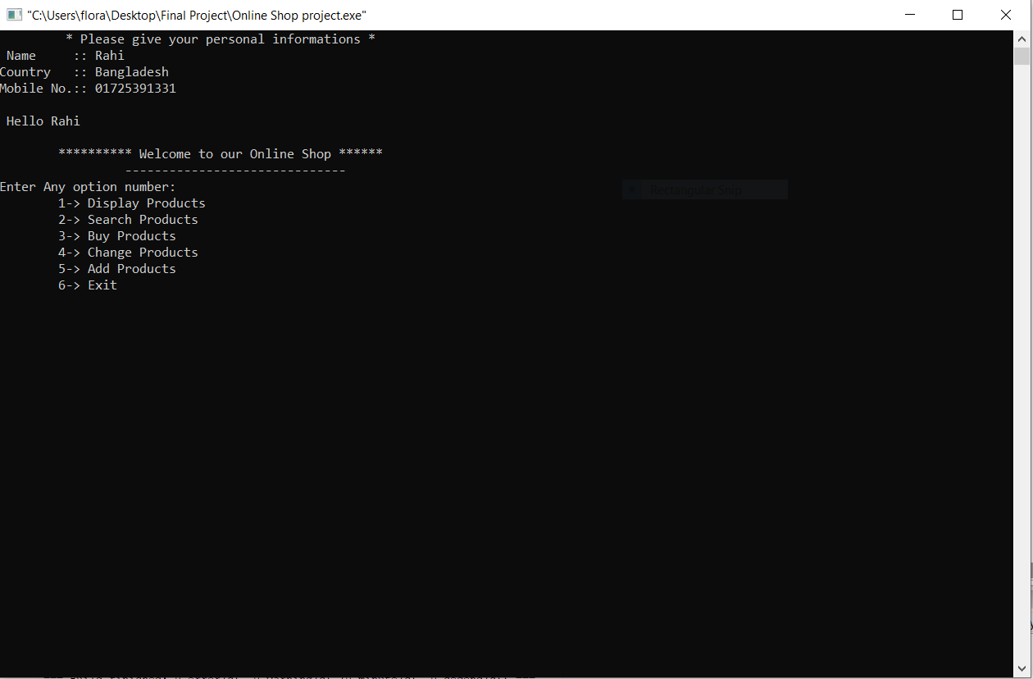

Display Products

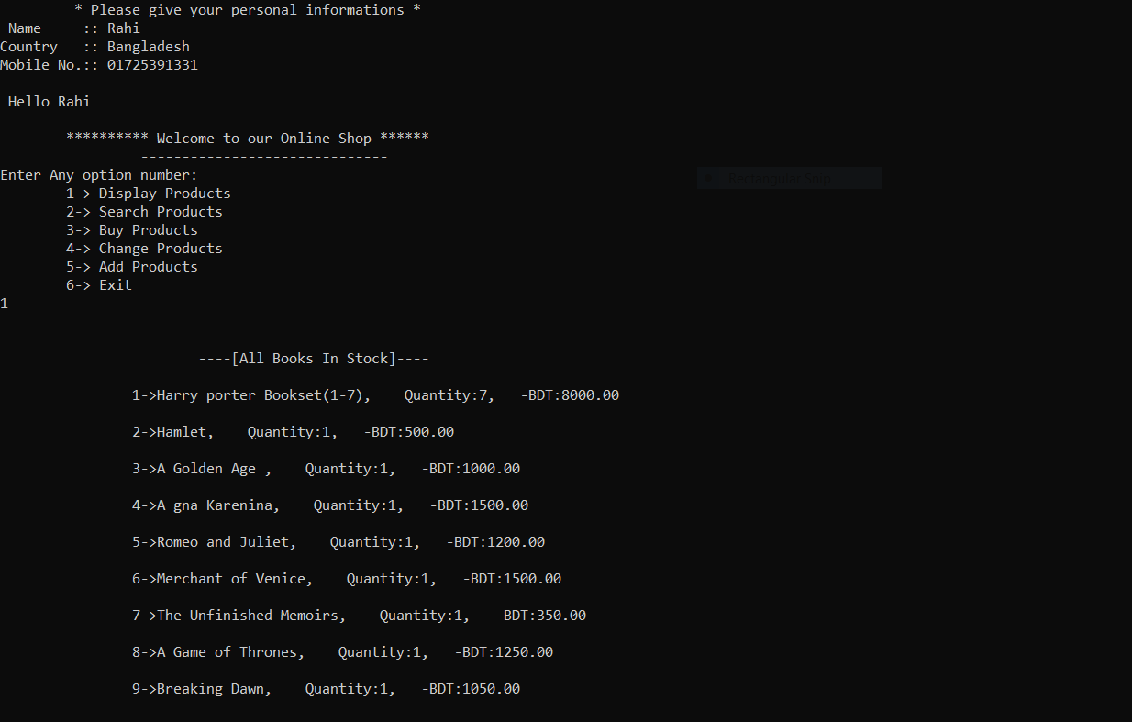

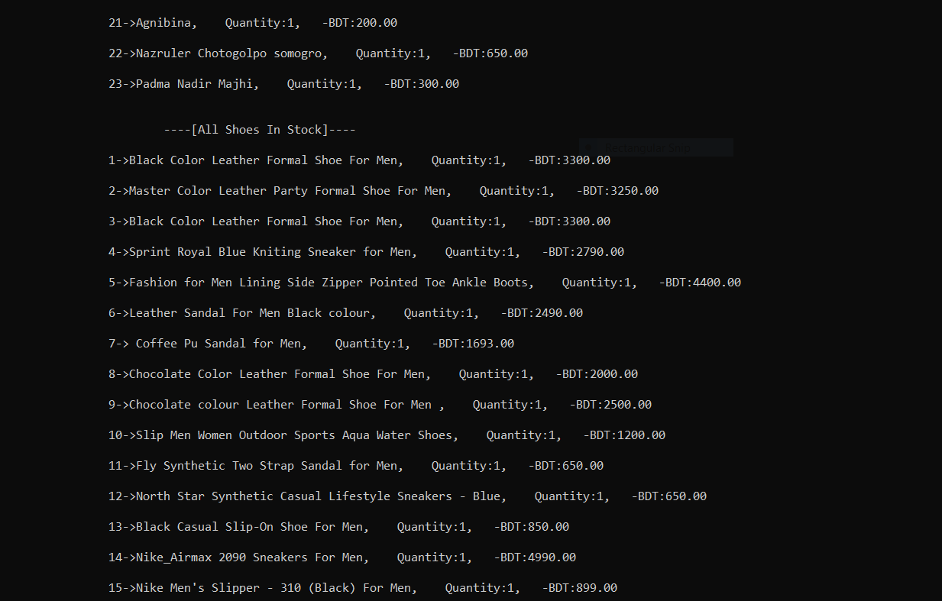

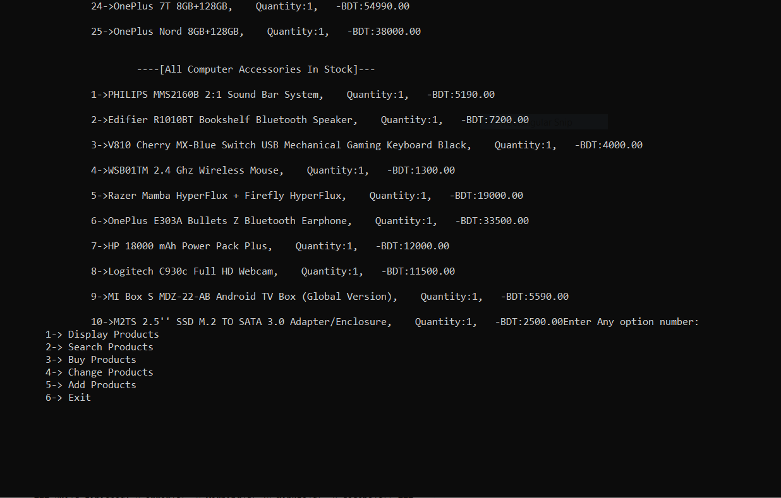

Search Products

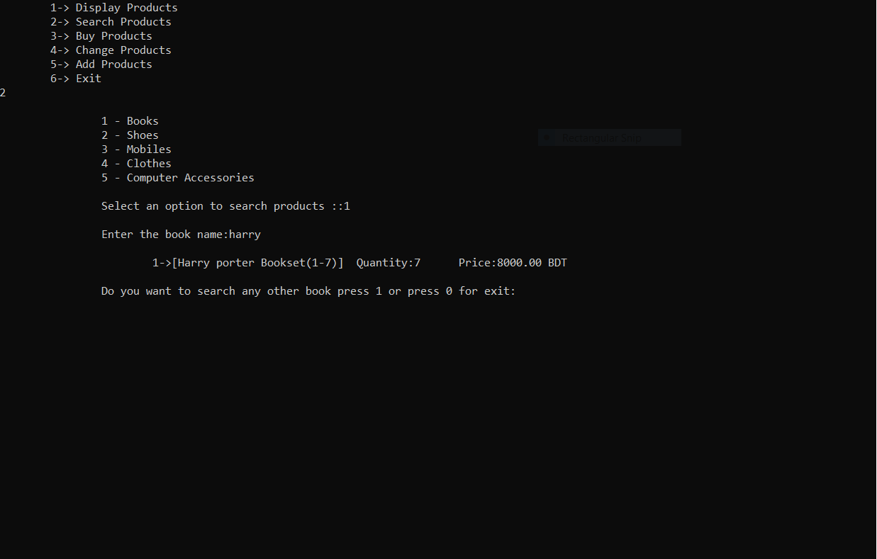

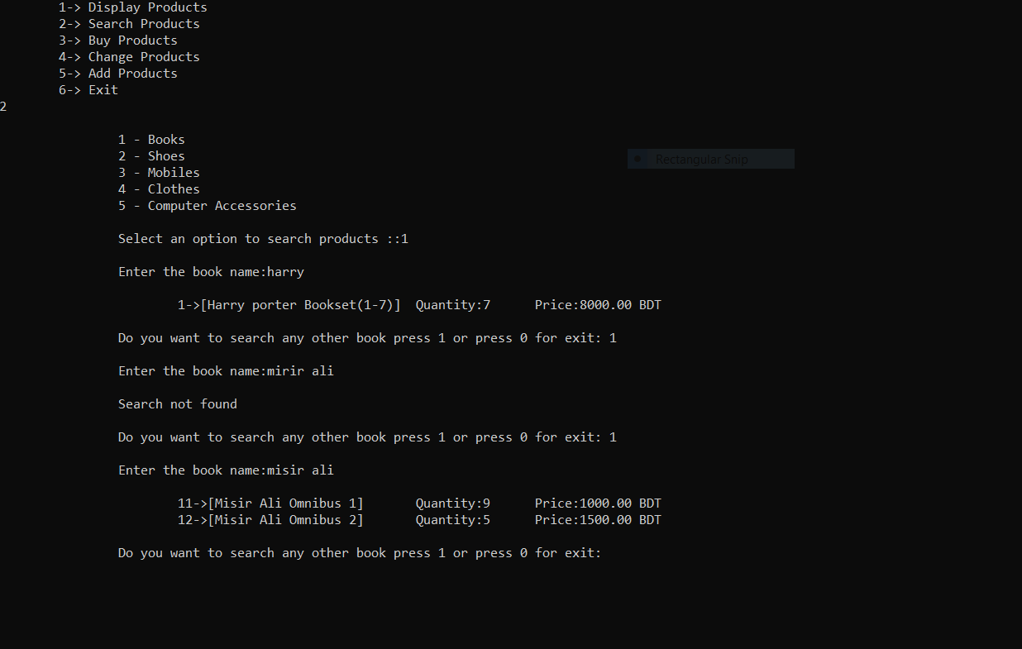

Buy Products

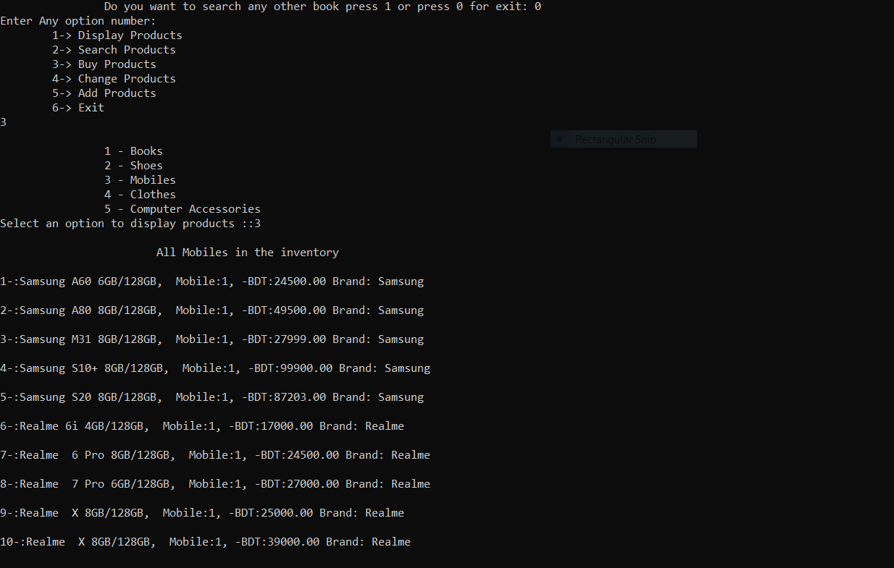

Buy another products

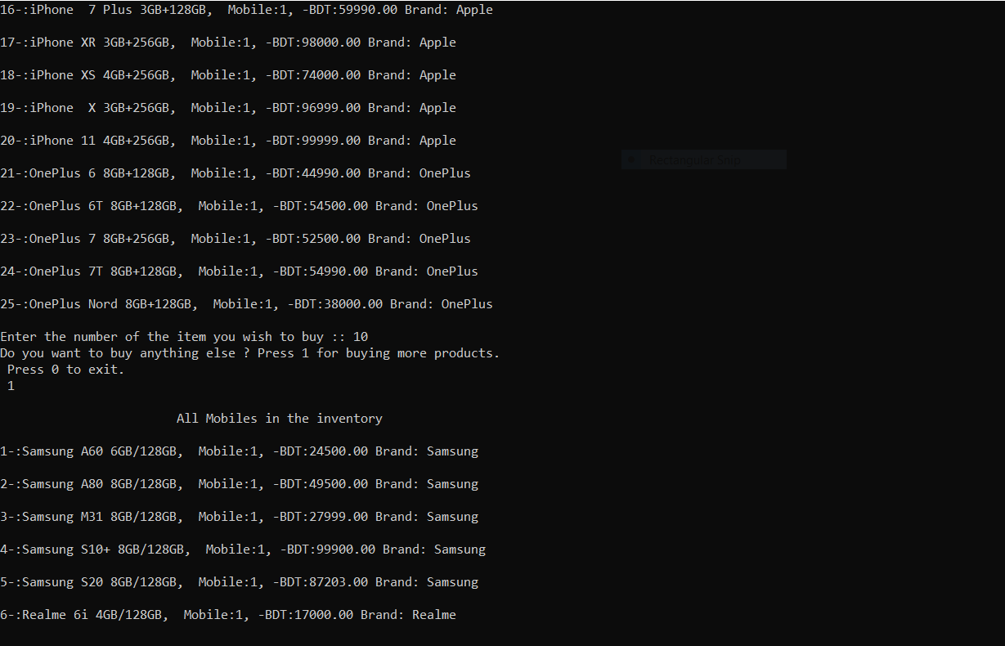

Total cost

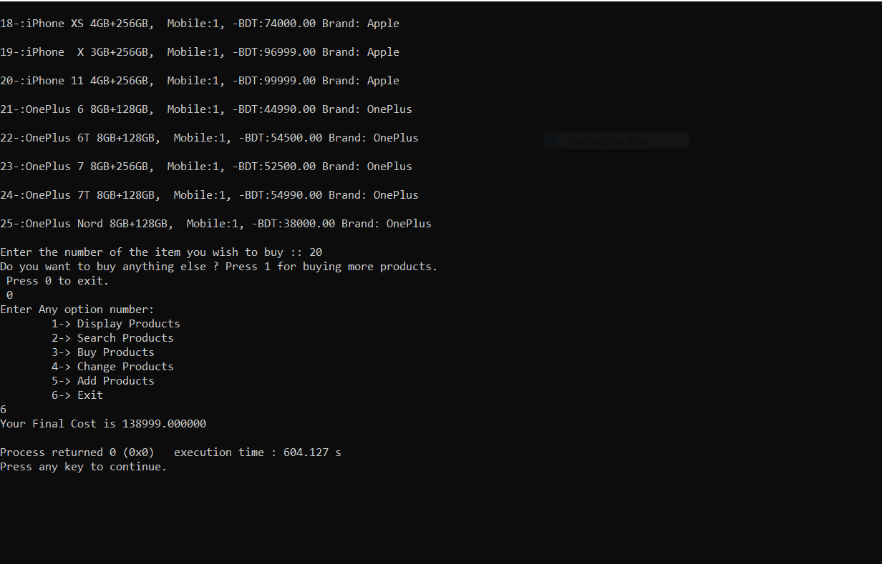

Request for changing product

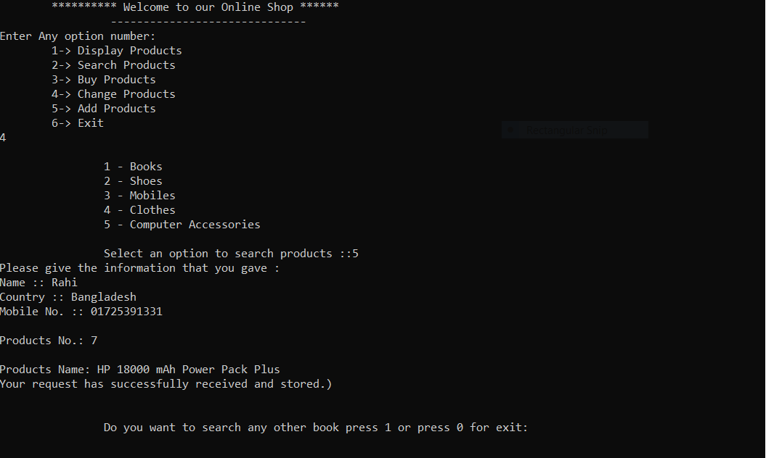

Add products

